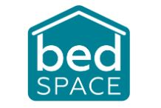
Bedspace Employee Benefits

• Career development and progression including funding for relevant qualifications

• Simply Health Cashback Plan (including dental, optical, prescriptions, medical appointments, and physiotherapy)

• Employee assistance programme offering 24/7 counselling and GP service available

• Life insurance (Equivalent to 4 times your annual salary)

• 33 days annual leave per year plus one day Birthday Leave

• Quarterly employee awards and ongoing recognition scheme

• Discount card to use at supermarkets and high street stores (launching November 2021)
• Company pension scheme (Salary sacrifice launching November 2021)

• Option to buy or sell annual leave

• Recruitment referral scheme

• Enhanced company sick pay

• Employee Volunteering Days (launching December 2021)

• Enhanced company maternity and paternity leave pay

