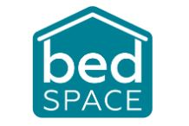
Bedspace Employee Benefits

- Competitive Rates of Pay
- Excellent training opportunities leading to career development
- Simply Health Care Cashback Plan (including children up to age 16)
- Life insurance
- 25 days annual leave plus Bank Holidays (pro-rated for part time staff)
- Birthday Leave
- Free Parking
- Ability to buy and sell annual leave (up to a maximum of 5 days per year).
- Pension with company contribution

